Ms. Anna’s Math World Name
Equations of Lines Period Date

Find the equation of the line in slope-intercept form with the given information.
1. m = 4; b = ½  Slope-Intercept: | 2. m is undefined and goes through (-2, 5)  Slope-Intercept:
3. m = 0 through (-4, -1)  Slope-Intercept: | 4. through the points (5, -8) and (3, -12)  Slope-Intercept:
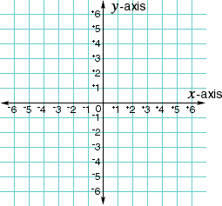  5.  Slope-Intercept: | 6. through (1, -2) m = -3  Slope-Intercept:
7. m = ¾ ; (4, -5)  Slope-Intercept: | 8. through the points (-9, 5) and (-13, -3)  Slope-Intercept:
Graph the following equations.
9. y = $\frac{3}{2}$x – 1 | 10. y = -2x + 3
11. x = -4 | 12. y = 4 – x
13. 6y – 2x = -12 | 14. y = 3
15. 2x + 2y = -8 | 16. x + 3y = 6

