Ms. Anna’s Math World Name:______________________
Percent Word Problems (Tax and tip) Date: __________

- Lucy went to the store to get a pet parakeet. The parakeet costs $20 and the store tax is 8.875%. You decide to tip the store owner 15%.

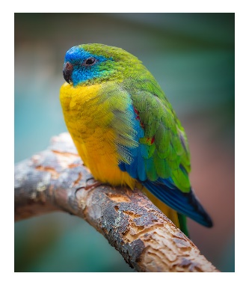
- How much money do you have to spend in total to buy a parakeet?
This Photo by Unknown Author is licensed under CC BY
z


- What is the tax and tip?

Baby parrotlets are practically blind and deaf when they are born.

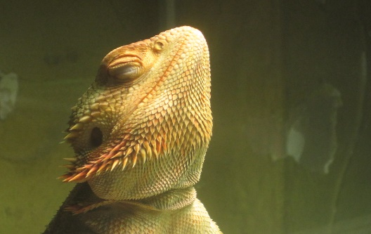
- Matilda goes to the store to buy a bearded dragon. A bearded dragon costs $50. The tax is 3% and you decide to tip 5%. How much will Matilda pay in total to buy a bearded dragon?
This Photo by Unknown Author is licensed under CC BY-ND
This Photo by Unknown Author is licensed under CC BY

When bearded dragons are born, they are
about the size of your pinky nail!

Fenix fox communicate in a high pitch yelplow quiet growl.
- BONUS! Extra practice. Change the following decimals into percents!
  - 5.7
  - 7.5
  - .050
  - .09993

