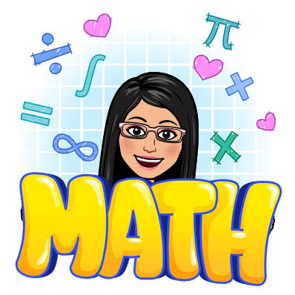
Ms. Anna’s Math World
1st grade math Curriculum

Targets:
- Numbers 1-10
- Number bonds
- Addition within 10
- Subtraction within 19
- Ordinal Numbers (naming position 1st, 2nd, 3rd, etc)
- Numbers to 20
- Addition and Subtraction using numbers bonds, counting and pictures
- Shapes
- Comparing and grouping shapes
- Number patterns with shapes
- Length
- Measuring length (long, longer, longest; short, shorter, shortest)
- Comparing lengths directly and indirectly using units
- Picture graphs
- Numbers to 40
- Counting by 10’s and ones
- Adding and subtracting ones
- Adding to make the next 10 (using addition facts)
- Subtracting from the tens (using subtraction facts)
- Adding 3 numbers!
- Time
- Tell time to the hour
- Tell time to the ½ hour
- Telling time to 5 minutes
- Money
- Coins
- Counting money
- Bills
- Shopping & practice

